
June 24 - 25, 2016

Friday 6:30—8:30 PM
Saturday 9:00 AM—4:00 PM

Fee: $119 at the door or $99* Early Registration Discount
(*Early Registration Discount Fee due by June 10th)

MINISTRY LEADERS ONLY

Open to all ministers, board members, licensed teachers, practitioners, lay leaders and key staff.

Hosted by
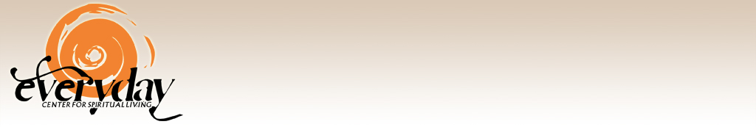
1519 5th St, Santa Fe, NM 87505
Phone:(505) 629-9633

Dr. Gary Simmons

Dr. Gary Simmons is co-minister of Unity Spiritual Center Spokane and co-founder of The Q Effect, LLC. He is also author of The I of the Storm, The Soul’s Conspiracy and co-author of The Art & Practice of Living with Nothing and No One Against You.

Transformational Leadership Development™ with Dr. Gary Simmons

w

Background
In 2009, Unity Worldwide Ministries and thirteen ministries began
a three-year pilot program to field-test a new paradigm of ministry
based on the doctoral work of Dr. Gary Simmons. Ten ministries
completed the program in 2012. The impact of this three-year project
has been deemed an outstanding success by the pilot ministry leaders.
(See http://www.unity.org/transform for a complete report and
review of the program.).

About this event
This training consists of three foundational modules integral to the
understanding and implementation of a new ministry practice, grounded
in integral theory and field-tested effective by the pilot program
ministries. These modules are: The Integral Model of Ministry, The
Ownership Project, and the newly developed Integral Membership
System.

Details
The Integral Model of Ministry—A Whole-System Approach to
Ministry Growth & Development

The Integral Model of Ministry is a new paradigm
of ministry that utilizes a whole-system approach
to engaging the challenges and opportunities of
ministry. Having won the personal praise of world-
renowned integral theorist and philosopher Ken
Wilber, Dr. Gary Simmons presents an overview
of the model and how it moves beyond the 400 year old Pastor Flock
model of ministry. This module provides a clear framework for under-
standing how common ministry related issues are not so much
problems to solve, but evolutionary drivers that need to be leveraged.
Participants will learn about ways to affect cultural and system change
that can lead to greater ownership and accountability.

.

The Ownership Project—Managing the Receivership/Ownership Polarity for Financial Sustainability
Church organizations have both a culture of receivership and a culture of ownership. In general, the culture of ownership is comprised of the 20% of the congregation that provides 80% of the financial resources needed to sustain the ministry. This means that the majority of the congregation, the culture of receivership, only provides 20% of the needed funds. Typically, the ministry leaders are not accustomed to differentiating the giving patterns between these two distinct cultures within the ministry. In fact, at times of financial challenge the tendency is to try to increase attendance as a strategy for increasing financial support. This strategy only increases the culture of receivership, resulting in greater expense, not income.

Managing the receivership/ownership polarity is essential to creating thriving, coherent and integral spiritual communities. The Ownership Project module presents effective strategies that translate into immediate shifts in giving patterns within the ministry. It exposes common myths held by ministry leaders about how to best deal with financial stress and provides a clear roadmap to sustainable ministry.


Integral Membership System
This module explores the benefits and challenges of implementing a graduated membership system that is designed to intentionally cultivate greater ownership of the ministry. It looks at a phased approach to seamlessly moving an individual from first-timer to governing member over time.
Participants will learn about Bylaws changes and implementation strategies integral to bring online this enhanced membership process.


(See www.unity.org/transform for Pilot Program results, and video/audio testimonies.)

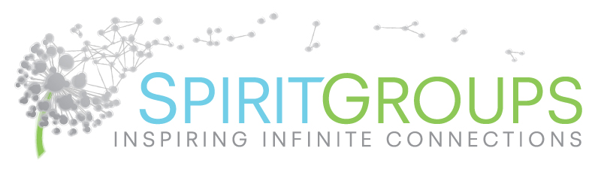
The final module of this training focuses on SpiritGroups.org, a small group ministry program created by Unity.fm’s brainchild and former director, Mendhi Audlin, L.U.T. She has studied the phenomenal success of the three largest churches in the U.S. and how their focus on small group ministry is transforming lives. While small group ministry is not a new concept, SpiritGroups is a powerful approach to small group ministry that prevents the creation of independent sub-cultures that can sometimes become problematic if not accountable to or aligned with the ministry's mission. Her program is affordable, scalable, and turnkey.

Transformational Leadership Development
Workshop—June 24 - 25, 2015
Early Registration & Payment Form

Please complete this form and return with payment by June 10th:
Everyday Center for Spiritual Living Seattle
1519 5th St, Santa Fe, NM 87505
Please print
Ministry Name

Ministry Address

City State Zip

Contact Person Phone ( )

Email
In order to receive the Early Bird Rate of $99/person*, please provide payment for the number of individuals from your ministry that will be attending. Payment must be received by June 10, 2016.
Number of early registrations X $99.00 = total
□ Payment by enclosed check □ Payment by credit card
Make check payable to: Everyday Center for Spiritual Living Seattle
Credit card type: □ Visa □ MC □ Discover □ AMX

Name on Card
Billing Address
Expiration Date Security Code
Card Number
Signature Date

* Please include a roster containing the names and email addresses for each person in your group. You may purchase seats to be filled later and add individuals at the door for the $99 rate, providing your group is pre-registered by June 10th.

